

Project Report Digital Literacy

Course
CSE001 DIGITAL LITERACY

Name MAYURAKSHI BHARADWAJ

Registration Number 25BOE10103

Branch BIOENGINEERING

Semester Winter Semester 2025-2026

Date 29th March 2025


INTRODUCTION

At VIT Bhopal, I have been appointed as a Student Digital Ambassador. The primary responsibility of this appointment is to provide guidance to my fellow students in the effective use of the internet, which includes assistance with creating an online professional profile and staying safe from cybercrime; therefore, the purpose of this report is to document my participation in five different modules of the Student Digital Ambassador program. The modules included creating an infographic, creating my professional portfolio, coding and collaboration, email etiquette, and researching online safety; through this work, I have created a digital portfolio of my skills and commitment to being a responsible member of the digital community.



Project Report

Student Digital Portfolio


INTRODUCTION

Forthis task, I established a foundational digital presence by setting up and updating profiles on GitHub, LinkedIn, and Kaggle. I chose these platforms because they are the primary tools used by the global tech community to track skills and professional growth. On GitHub, I created a profile README to introduce myself as a Gaming Technology student, ensuring my branch and learning goals are visible to anyone visiting my profile. On LinkedIn, I updated my education section to reflect my current B.Tech degree at VIT Bhopal.

Overthe next four years, I plan to use these platforms as a live archive of my progress. I will use GitHub to host my coding projects and version control my game development scripts, while Kaggle will help me explore the data-driven side of AI. LinkedIn will serve as my main networking hub for finding internships and connecting with industry professionals in the gaming sector. Setting these up now ensures that by the time I graduate in 2029,

Iwill havea comprehensive, professional history that proves my technicalabilities and consistency.



Project Report

Digital Literacy
Essentials


INTRODUCTION

Forthis module, I explored technical practice and digital collaboration using HackerRank and Google Workspace. On HackerRank, I completed a beginner Python challenge to strengthen my foundational logic, which is essential for my studies in Computer Science. This platform demonstrated how gamified learning and immediate feedback can help a student track their technical progress.
In addition to coding, I developed a five-question Digital Literacy Awareness Quiz using Google Forms to engage my peers as a Digital Ambassador. I included a mix of multiple-choice and shortanswer questions to cover topics like safe browsing and professional profile

management. I also set up a linked Google Sheet to monitor responses, which highlighted the efficiency of cloud-based collaboration tools. Academically, mastering these tools allows me to coordinate group projects at VIT Bhopal more effectively and manage data systematically. This task reinforced that being digitally literate means not only writing code but also knowing how touse collaborative platforms to communicate and gather information.



Project Report

Professional
Communication & Etiquette


Objective

AsaStudentDigital Ambassador, my objective for this module wastodemonstrate effective digital communication and develop a guidefor responsible social media use within the VIT Bhopal
community. This involved mastering the "digital handshake"—the professional tone required for academic and career-related interactions.


Professional Email Drafts

Ideveloped two formal email templates to handle common student scenarios:
- Email 1: Assignment Extension Request ○ Subject: Extension Request Mayurakshi Bharadwaj (25Boe10103).
- Context: This draft addresses a situation where technical difficulties, such as weak hostel Wi-Fi, prevent a timely submission. It uses a respectful tone and provides a specific new
deadline. ● Email 2: Internship Inquiry
  - Subject: Internship Inquiry: Summer 2026 Mayurakshi Bharadwaj
(25Boe10103).
  - Context: Targeted at industry coordinators, this email
highlights my specialization in bioengineering and
references
my technical projects, such as the Pythonbased medicine checker system, to build professional
credibility.


Social Media Etiquette Checklist

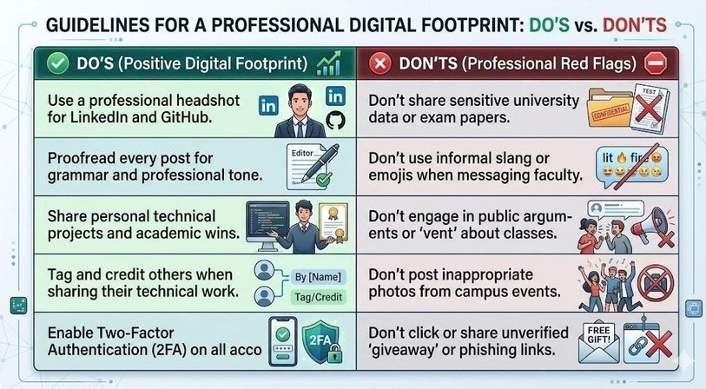


Reflection

AsaStudent Digital Ambassador, I have observed that many communication challenges arise from a lack of clear context. A common scenario is when students send informal messages to

faculty without subject lines or registration details, leading to unnecessary delays and confusion. Drafting these formal emails taught me that professional etiquette is about providing the recipient with all necessary information to help you effectively. For example, in my extension request, citing weak hostel Wi-Fi provided a grounded, realistic reason for the delay. Furthermore, the internship inquiry allowed me to showcase my technical identity, specifically my specialization in bioengineering and my Python projects. Moving forward, I realize that a professional "digital handshake" is the first step toward building credibility and ensuring my academic and professional requests are handled successfully.



Study:
UPI Spoofing and QR Code

Project Report
Cybercrime Awareness
& Prevention
Case

Inmy research as a Student Digital Ambassador, I focused on UPI Spoofing, a rapidly growing threat in 2026. Scammers use fraudulent applications that mimic the user interface of popular UPI wallets (like GPay or PhonePe) to show a fake "Payment
Scams
Successful" screen. This trick is often used against students selling items online or local vendors. Another common tactic is the QR Code Scam, where victims are tricked into scanning a code to "receive" money, but in reality, scanning and entering a PIN only authorizes a deduction from their own account.


8-Tip Prevention Checklist

Toprotect yourself and your classmates from these financial threats, follow these essential safety rules:
- PIN is only for Sending: Never enter your UPI PIN or scan a QR code to receive money.
- Verify the Recipient: Always double-check the name displayed on your app screen before hitting 'Pay'.
- Use Official Apps Only: Never download "screen-sharing" or "remote access" apps (like AnyDesk) on the instructions of a stranger.
- Check Bank SMS: Confirm that money has actually been credited via your bank's official SMS or app, not just by looking at a sender's screenshot.
- Decline 'Collect' Requests: Be wary of unexpected notifications asking you to "Approve" a payment request. 6.

Secure YourDevice: Use biometric locks and Two-Factor Authentication (2FA) for all financial and social media accounts.
- LimitDailyTransactions: Set a sensible daily limit on your
UPIapptominimize potential losses if a breach occurs.
- ReportImmediately: If fraud occurs, call the National CybercrimeHelpline at 1930 or visit cybercrime.gov.in withinthe"Golden Hour" to freeze the transaction.
○


Reflection

Researching UPI fraud was a significant eye-opener for me. As a Computer Science student specializing in AI & ML, I considered myself tech-savvy, but I realized how sophisticated social
engineering has become in 2026. Scammers don't just use technical glitches; they exploit a student's sense of urgency or lack of experience with digital payments.

Onemajor habit I am changing is my level of caution when scanning QRcodes in public spaces or while using online marketplaces. I’ve alsoshared the 1930 helpline details with my hostel batchmates, asmany were unaware of the "Golden Hour" for reporting fraud.
Thistask reinforced that being a Digital Ambassador isn't just aboutbuilding profiles; it’s about maintaining the vigilance required toprotect our financial identities. Digital literacy is our first and strongest line of defense against these evolving threats.

